Analysis of the Airbnb

Airbnb is an online marketplace that allows people to rent out their homes, rooms, or unique spaces to traveler’s worldwide. It connects people who have extra space to rent—such as homes, apartments, rooms, villas, or other unique stays—with travelers looking for accommodation. It provides an alternative to traditional hotels by offering a wide range of lodging options to suit different budgets, preferences, and travel styles. Through its platform, hosts can list their properties, while guests can browse, compare, book, and review stays from around the world. Airbnb has transformed the travel industry by making travel experiences more flexible, personalized, and accessible.

In this project, I used Python for cleaning, MySQL for building KPIs, and Power BI for creating a dashboard and visualisation. The main aim was to perform exploratory data analysis on Airbnb listings and identify the key factors affecting pricing, availability, reviews, and overall listing performance.

Data Cleaning Report

Airbnb Listings Dataset

Data cleaning was done in Python (Google Colab) here is the link to the Colab file: link 1, link 2
The cleaned dataset is more analysis-ready than the raw file. Text-heavy fields were converted into structured variables, several derived features were added, non-numeric price values were normalized, and duplicate listing IDs were substantially reduced.
Metric | Raw file | Cleaned file | Observation
Rows | 14,456 | 13,621 | -835 rows
Columns | 13 | 17 | +4 columns
Unique listing IDs | 13,724 | 13,607 | 12,022 IDs overlap
Duplicate IDs (unique IDs repeated) | 652 | 14 | Strong duplicate reduction
Rows involved in duplicate IDs | 1,384 | 28 | Near-deduplication

Standardized schema and column names
The cleaned file keeps the core listing fields and reorganizes messy text columns into more meaningful analysis columns. For example, 'hostnames' was split into 'Property type' and 'Hostname', while 'price' became the numeric field 'Price_in_Rupees'.

Converted text fields into numeric variables
Several fields in the raw file were stored as text. In the cleaned file, rating, reviews, price, guest count, bedroom count, and host ID are numeric or numeric-like, which makes them suitable for filtering, aggregation, and modelling.

Split compound text columns into structured attributes
The raw dataset stored multiple pieces of information inside single text string. The cleaned file extracts structured fields from these strings, which is one of the greatest improvements in the dataset.

Created derived binary amenity indicators
Instead of keeping only a long comma-separated amenities field, the cleaned file introduces analysis-friendly indicator columns for commonly used amenities such as Wi-Fi, Kitchen, and Parking.

Treated 'New' listings separately
In the raw data, many values in the rating column were recorded as 'New' rather than as a numeric rating. In the cleaned file, this information appears to have been moved into a new binary flag called 'Newlisting', while the numeric rating field was left blank for those cases.

Reduced duplicate records and filtered problematic rows
Duplicate listing IDs were sharply reduced from 652 repeated IDs in the raw file to only 14 repeated IDs in the cleaned file. The total row count also decreased, indicating that some rows were removed or consolidated during cleaning.

Handled missing and inconsistent values
Missing values were reduced for several important fields. For example, host_id is fully populated in the cleaned file, and derived columns such as No_of_Guests, No_of_bedrooms, Price_in_Rupees, Country, and amenity flags contain no missing values.

Main improvements achieved:
• Converted price and several textual fields into usable numeric columns
• Extracted property, host, geography, capacity, and amenity features
• Added a new listing indicator
• Greatly reduced duplicate IDs
• Produced a dataset that is more model-ready and reporting-friendly

Key Performance Indicators (KPIs)
- Main dashboard KPI query in sql 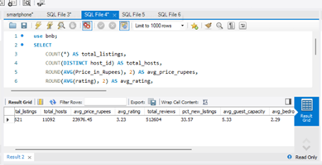

- Property-type KPI
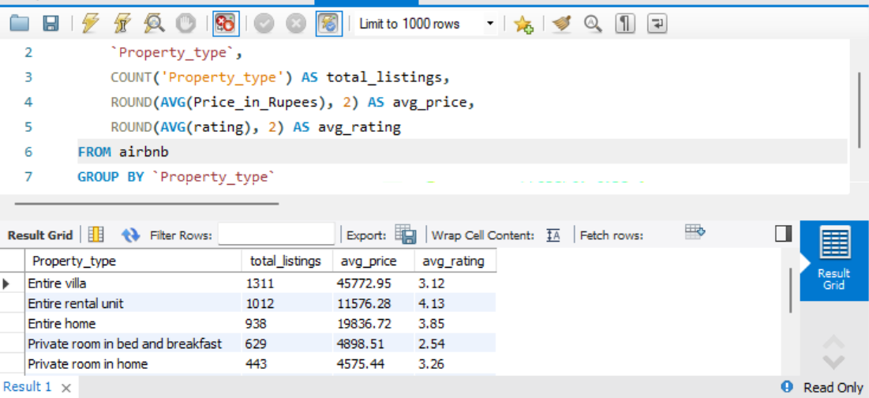

- For each country, what fraction of listings have a rating >= 4.5
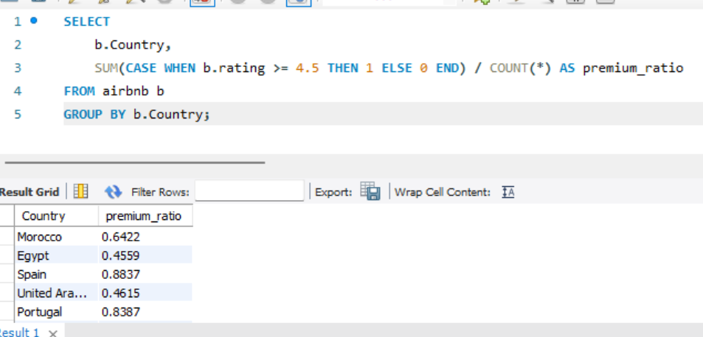
Many such KPIs were created in MySQL and used for analysis purpose.

Visualisation (In Power BI)
For plotting the visuals, I had used Power BI. A dashboard was created in which I had plotted the graphs and built the KPIs, which helped to bring insight from the dataset.
Here is a screenshot of the Dashboard,
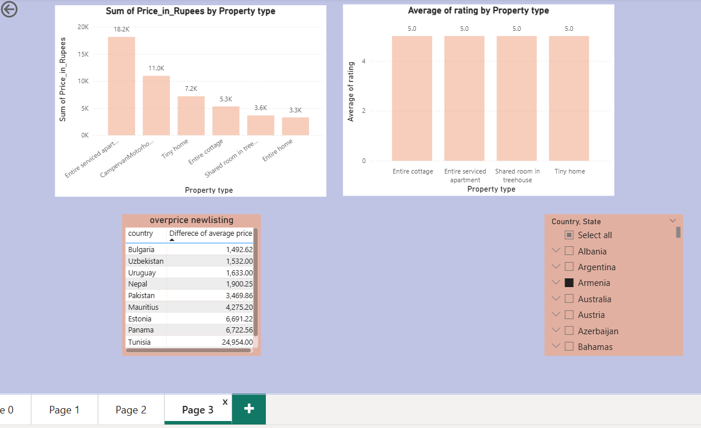

Solution Of a Business Problem
The dataset shows a broad global Airbnb market with strong price dispersion. The average nightly price is much higher than the median, which indicates a small number of premium listings pulling the average upward. Demand is proxied through reviews because booking and revenue fields are not available. About 81% of listings have at least one review, while 33.6% are marked as new listings.
  - Listings analysed: 13,621
  - Distinct hosts: 11,092
  - Countries: 119
  - Average price: INR 23,976
  - Median price: INR 8,444
  - Average rating: 4.86
  - Listings with reviews: 81.0%
  - New listings: 33.6%
Key Problem Solutions:

- India has the largest number of listings in the cleaned sample, followed by Italy, Greece, and Thailand. Italy and Thailand show much higher average prices than India, which indicates different market positioning and property mix across countries.

- In data, we see that people like Property of type, which are private or entire of customer. They do not like to share their area with others.

- Using total reviews as a popularity score, Bali, England, and Goa stand out among the strongest destination clusters in the sample. This result is directionally useful for market selection. Again, we can see prices are very low in India, even for tourists.

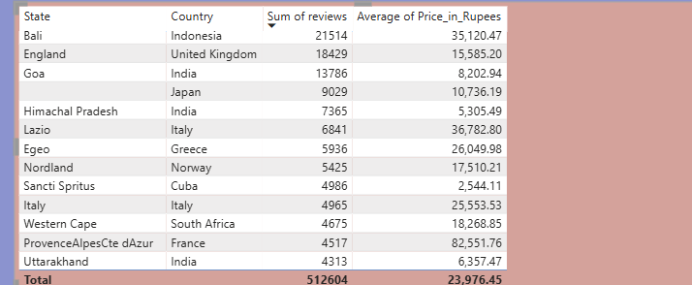

.
- Basic amenities are not available on every property
- Compete on clarity and fit by property type, Entire villas and homes attract large supply, while segments such as rental units and cabins show strong review traction. Owners should tailor messaging to the segment rather than using generic listing copy.

